BUMK744 Team Assignment II - Interpretation and Chart Brief
Customer Segmentation using PCA and K-Means Clustering

1. Project Overview
- Business question: How can a retail company use customer demographic, spending, purchase behavior, and campaign-response data to identify meaningful customer segments and design better targeted marketing campaigns?
- Dataset: Customer Personality / Marketing Campaign data. The analysis uses customer-level data including income, age, household composition, product spending, purchase channels, recency, and campaign response.
- Methods used: Principal Component Analysis (PCA) and K-Means clustering. PCA summarizes the original customer variables into broader behavioral dimensions, and K-Means converts those dimensions into actionable customer segments.
- Recommended presentation storyline: Raw customer data -> cleaning and feature engineering -> PCA dimensions -> K-Means clusters -> customer segment names -> targeted marketing recommendations.

2. Data Preparation Summary
Step | What Was Done | Reason
Missing values | Dropped 24 rows with missing Income. | Income is central to segmentation; missing count was small.
Feature engineering | Created Age, Children, TotalSpend, TotalPurchases, CustomerTenureDays, and TotalCampaignAccepted. | Raw columns were converted into clearer marketing concepts.
Outlier handling | Removed customers above age 100. | Extreme/impossible ages can distort PCA and K-Means.
Column removal | Dropped ID, Z_CostContact, and Z_Revenue. | ID is an identifier; Z_CostContact and Z_Revenue are constant columns.
Standardization | Standardized all modeling variables before PCA. | Variables are measured on different scales, so standardization prevents large-scale variables from dominating.

3. PCA Learnings
PCA was used to reduce the original 16 standardized modeling variables into fewer underlying behavioral dimensions. We retained five principal components because they explain approximately 68% of total variance and each component has a meaningful marketing interpretation.
Component | Approx. Variance / Evidence | Interpretation | Managerial Meaning
PC1 | High loadings on Income, product spending, catalog/store purchases. | Customer Value / Spending Intensity | Higher PC1 customers are high-value, higher-spending customers.
PC2 | High loadings on deal purchases, web purchases, tenure, children. | Deal-Seeking / Web-Engaged Behavior | Higher PC2 customers are more promotion-sensitive and digitally active.
PC3 | Strong loading on Age, positive Income/Children, negative tenure. | Older Affluent Newer Customers | Captures an older, somewhat higher-income profile that is newer to the company.
PC4 | Recency loading is almost 1.0. | Purchase Recency / Recent Engagement | Higher PC4 means longer time since last purchase; lower PC4 means more recently active.
PC5 | Positive on wine spending and tenure; negative on children/deal purchases. | Wine-Oriented Loyalty vs. Deal-Oriented Family Shopping | Separates longer-tenured wine-oriented customers from deal/family-oriented shoppers.

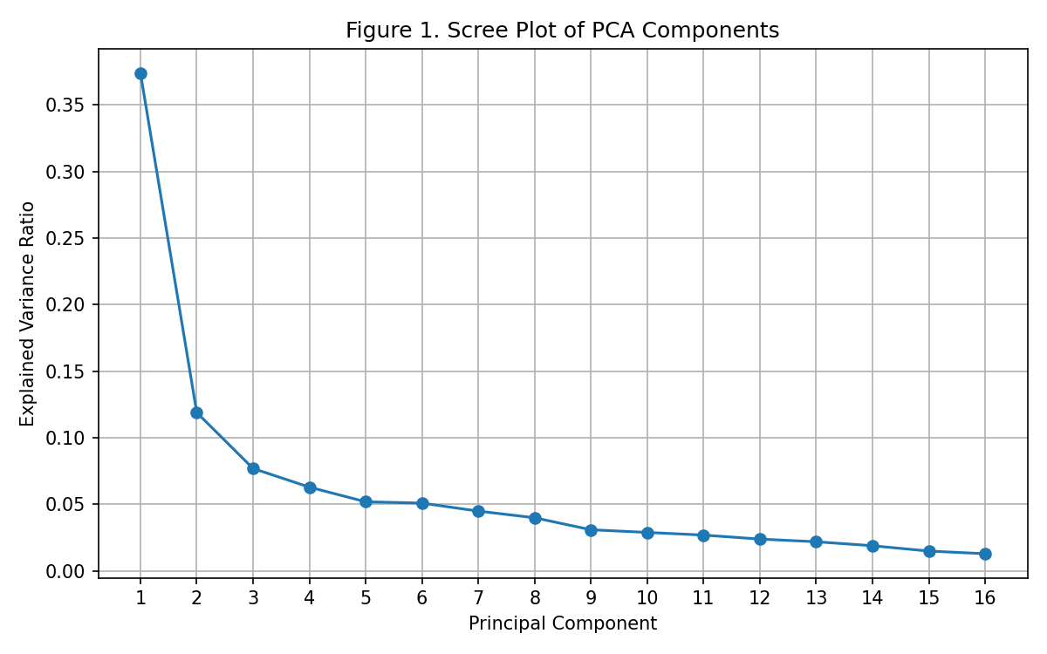
Figure 1. Scree Plot of PCA Components

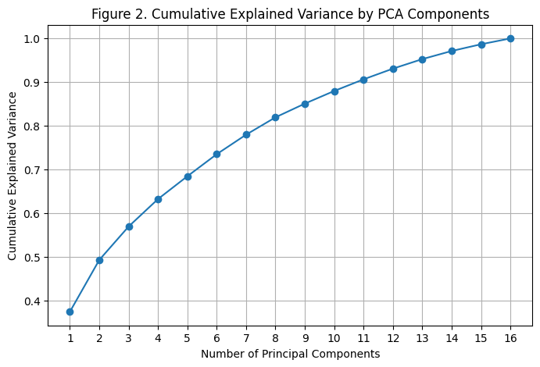
Figure 2. Cumulative Explained Variance by PCA Components
Key takeaway: PCA shows that customer behavior is organized around customer value, deal/web engagement, age/newness, recency, and wine/family-deal orientation. These five PCA scores were then used as the input for K-Means clustering.

4. K-Means Clustering Learnings
Instead of clustering on the original 16 standardized variables, K-Means was run on the five retained PCA score columns. This groups customers based on broader behavioral dimensions rather than many correlated raw variables.

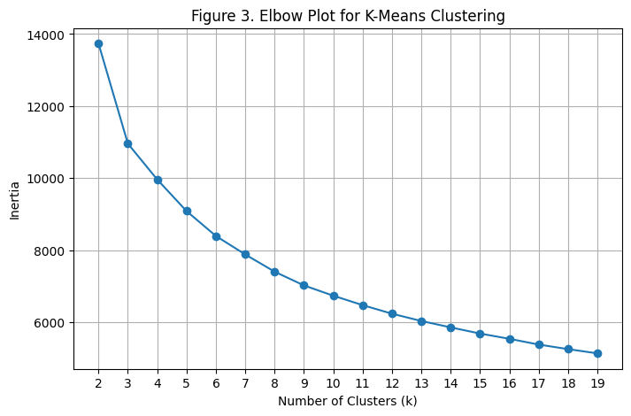
Figure 3. Elbow Plot for K-Means Clustering

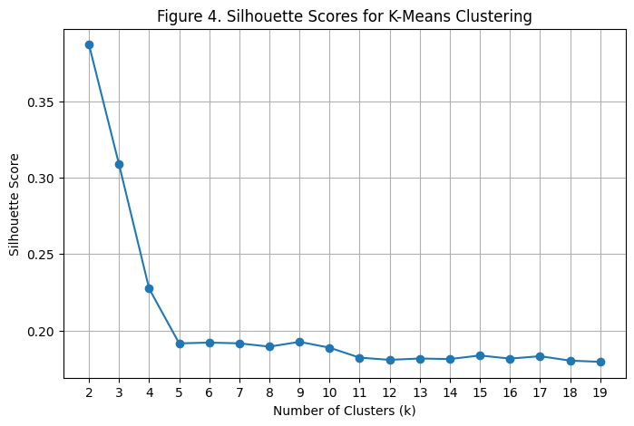
Figure 4. Silhouette Scores for K-Means Clustering
Cluster decision: The elbow plot suggested meaningful improvement through about 4-6 clusters. Although the silhouette score was highest for smaller cluster solutions, a four-cluster solution was selected because it produced more actionable and balanced marketing segments.

5. Segment Interpretation and Recommended Actions
Cluster | Segment Name | Key Numbers | Interpretation | Recommended Marketing Action
0 | Low-Engagement Family Customers | Size: 540; Income: $43,691.92; Age: 47.99; Children: 1.44; Total Spend: $137.67; Purchases: 6.94; Web Visits: 5.17; Campaign Acceptance: 0.13 | Moderate-low income, most children at home, low spend, low purchases, and weakest campaign response. Likely more budget-conscious or less attached to the brand. | Use practical value offers, household essentials bundles, and selective reactivation. Avoid over-investing premium budget.
1 | Premium High-Value Customers | Size: 600; Income: $76,645.10; Age: 45.65; Children: 0.24; Total Spend: $1,346.50; Purchases: 19.64; Web Visits: 2.82; Campaign Acceptance: 0.90 | Highest income, highest spending, highest purchase volume, and strongest campaign acceptance. This is the company’s strongest customer segment. | Prioritize premium bundles, loyalty rewards, early access, personalized cross-sell, and VIP retention.
2 | Deal-Seeking Omnichannel Families | Size: 529; Income: $57,259.12; Age: 49.23; Children: 1.21; Total Spend: $776.03; Purchases: 17.41; Deal Purchases: 4.10; Web Purchases: 6.63; Store Purchases: 7.64; Campaign Acceptance: 0.49 | Valuable but promotion-sensitive. Purchases frequently across web and store, with the highest deal purchases. | Use personalized coupons, loyalty points, family bundles, targeted promotions, and online-to-store campaigns.
3 | Young Digital Browsers / Low Converters | Size: 544; Income: $28,913.20; Age: 37.53; Children: 0.98; Total Spend: $92.98; Purchases: 5.63; Web Visits: 7.38; Campaign Acceptance: 0.23 | Youngest and lowest-income group. Lowest spend and purchase activity, but highest monthly web visits. Digitally engaged but not converting strongly. | Use retargeting, welcome offers, browse-abandonment emails, entry-level offers, and digital conversion campaigns.

6. Cluster Visualization

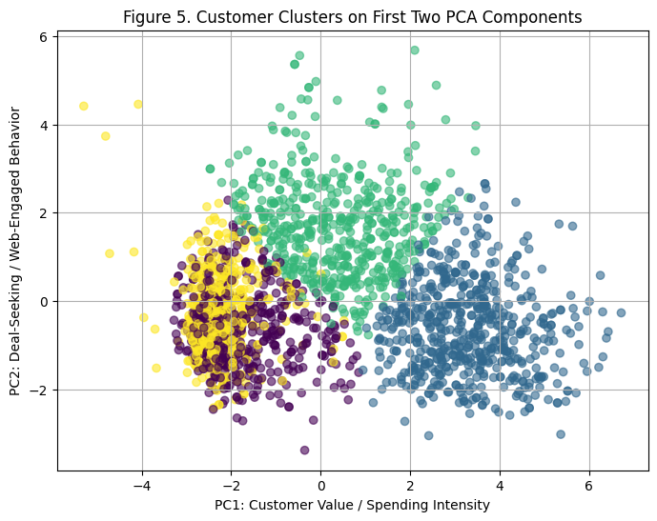
Figure 5. Customer Clusters on First Two PCA Components

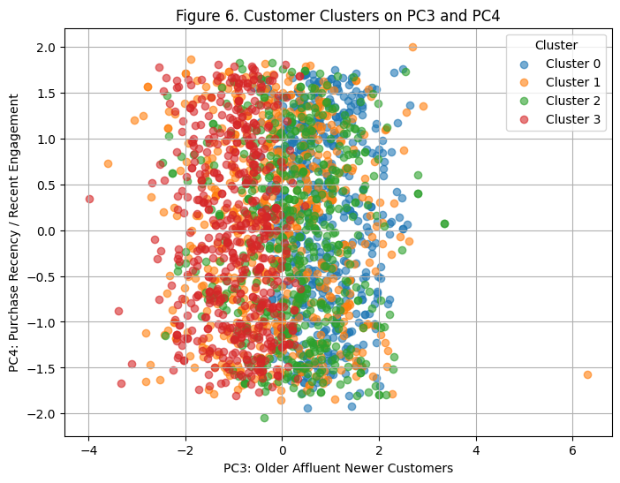
Figure 6. Customer Clusters on PC3 and PC4
Figure 5 is the strongest chart for the presentation because it shows how the four clusters separate on PC1 (customer value/spending intensity) and PC2 (deal-seeking/web engagement). Figure 6 adds a second view based on PC3 and PC4, showing how clusters differ by age/newness and recency.

7. Suggested Presentation Flow
Slide | Topic | Content
Slide 1 | Business Problem | Customer segmentation for targeted marketing campaigns.
Slide 2 | Dataset and Cleaning | Marketing campaign dataset, missing income handling, engineered variables, outlier removal.
Slide 3 | PCA Method | Why PCA was used and why five components were retained.
Slide 4 | PCA Learnings | Explain PC1-PC5 in marketing language.
Slide 5 | K-Means Method | Explain clustering on PCA scores and choice of four clusters.
Slide 6 | Segment Profiles | Show segment table with key numbers.
Slide 7 | Recommendations | Different marketing actions by segment.
Slide 8 | Limitations and Conclusion | Observational data, cluster choice sensitivity, no profit/cost data.

8. GitHub Upload Instructions
- Create a new GitHub repository, for example: bumk744-customer-segmentation.
- Upload the Colab notebook file: Marketing_Research_Team_Assignment_2.ipynb.
- Add a README.md with a short project description, methods used, and instructions to open the notebook in Google Colab.
- Optional but recommended: upload the dataset CSV if you want the repository to be fully self-contained. If you keep the current raw GitHub data URL in the notebook, make sure the link still works.
- In Google Colab, use File -> Save a copy in GitHub if you want to push the notebook directly from Colab.
- After uploading, click the notebook file in GitHub, copy the URL, and share it with teammates. For submission, use the Google Colab share link if the professor specifically requested Colab access.

9. Final Conclusion
This project used PCA and K-Means clustering to identify meaningful customer segments from retail marketing campaign data. PCA reduced the original customer variables into broader behavioral dimensions, including customer value, deal-seeking behavior, purchase recency, and product/channel preferences. K-Means clustering then converted these dimensions into four actionable customer segments: Premium High-Value Customers, Deal-Seeking Omnichannel Families, Low-Engagement Family Customers, and Young Digital Browsers / Low Converters. The results suggest that the company should use differentiated marketing strategies rather than one generic campaign for all customers.

